By ĐỖ VŨ KHÁNH QUỲNH - SWS00657
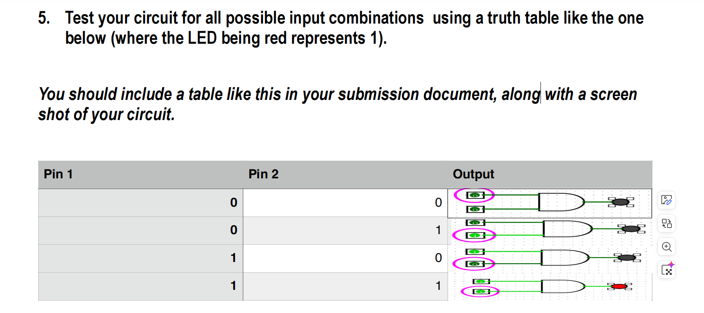
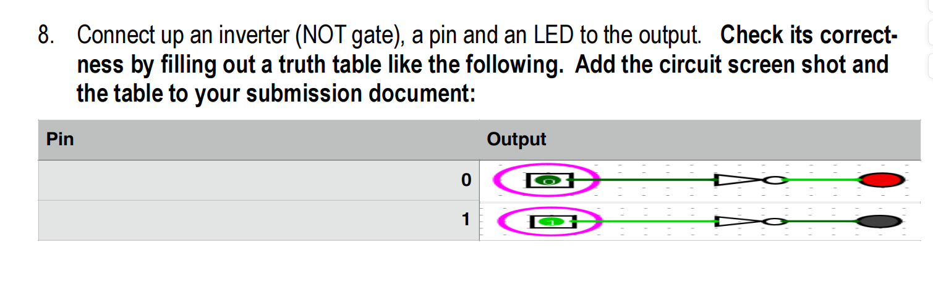
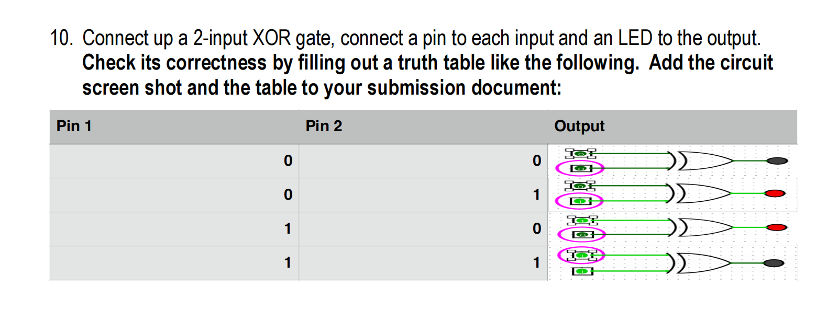
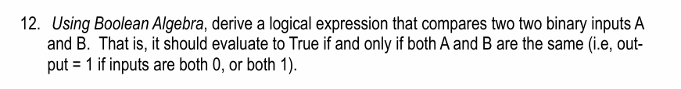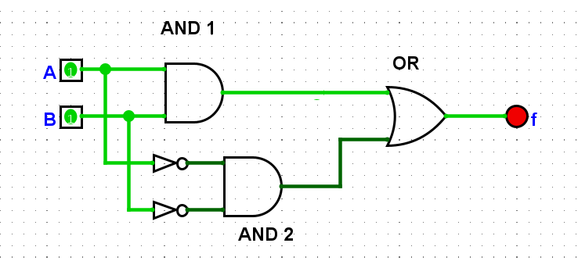
BOOLEAN ALGEBRA:
AND 1: A*B
NOT GATE => AND 2: $\overline{A}∗\overline{B}$
=> f = (A*B)+( $\overline{A}∗\overline{B}$)

A | B | f (output)
0 | 0 | 1
0 | 1 | 0
1 | 0 | 0
1 | 1 | 1

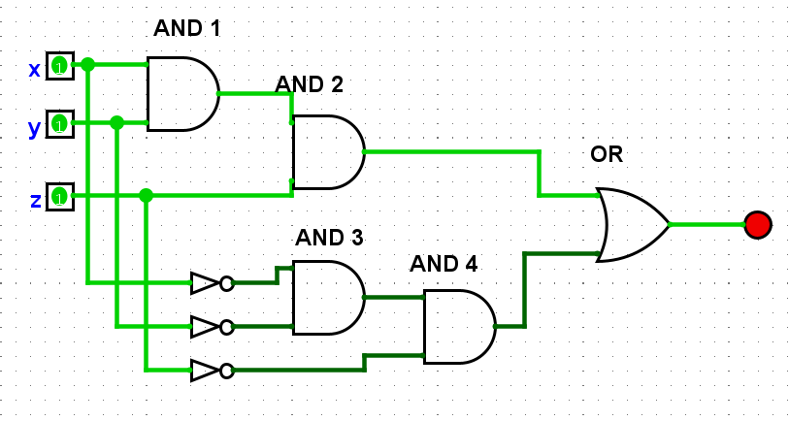
BOOLEAN ALGEBRA:
And 1: x*y
And 2: x*y*z
And 3:$\overline{x∗y}$
And 4: $\overline{x∗y∗z}$
=> f = (x*y*z)+$\overline{(x∗y∗z)}$

x | y | z | f (output)
0 | 0 | 0 | 1
0 | 0 | 1 | 0
0 | 1 | 0 | 0
0 | 1 | 1 | 0
1 | 1 | 1 | 1
1 | 0 | 0 | 0
1 | 0 | 1 | 0
1 | 1 | 0 | 0

